**12. ReactJS – HOL**

**Objectives**

* **Explain about conditional rendering in React**

Conditional rendering means show something only if a condition is true.  
If a user is logged in - show “Welcome”  
If not logged in - show “Please login”

Example:

*function App() {  
 const isLoggedIn = true;  
 if (isLoggedIn) {  
 return <h1>Welcome!</h1>;  
 } else {  
 return <h1>Please Log In</h1>;  
 }  
}*

* **Define element variables**

Element variables are just variables that store JSX elements. You can build, store, and reuse parts of your UI using them.  
  
i) To store dynamic UI  
ii) To conditionally show one element or another  
iii) To avoid repeating code

* **Explain how to prevent components from rendering**

You can prevent rendering using conditions (just like if-else) and returning null.  
  
Example:  
*function Welcome(props) {  
 if (!props.show) {  
 return null; // do not render anything  
 } return <h1>Welcome, User!</h1>;  
}*

**EXERCISE – 2:** Creation of a Ticket Booking App

Step 1: Open **VS Code**

Step 2: Create a New React App

**npx create-react-app ticketbookingapp**  
Step 3: Navigate into the project folder

**cd ticketbookingapp**

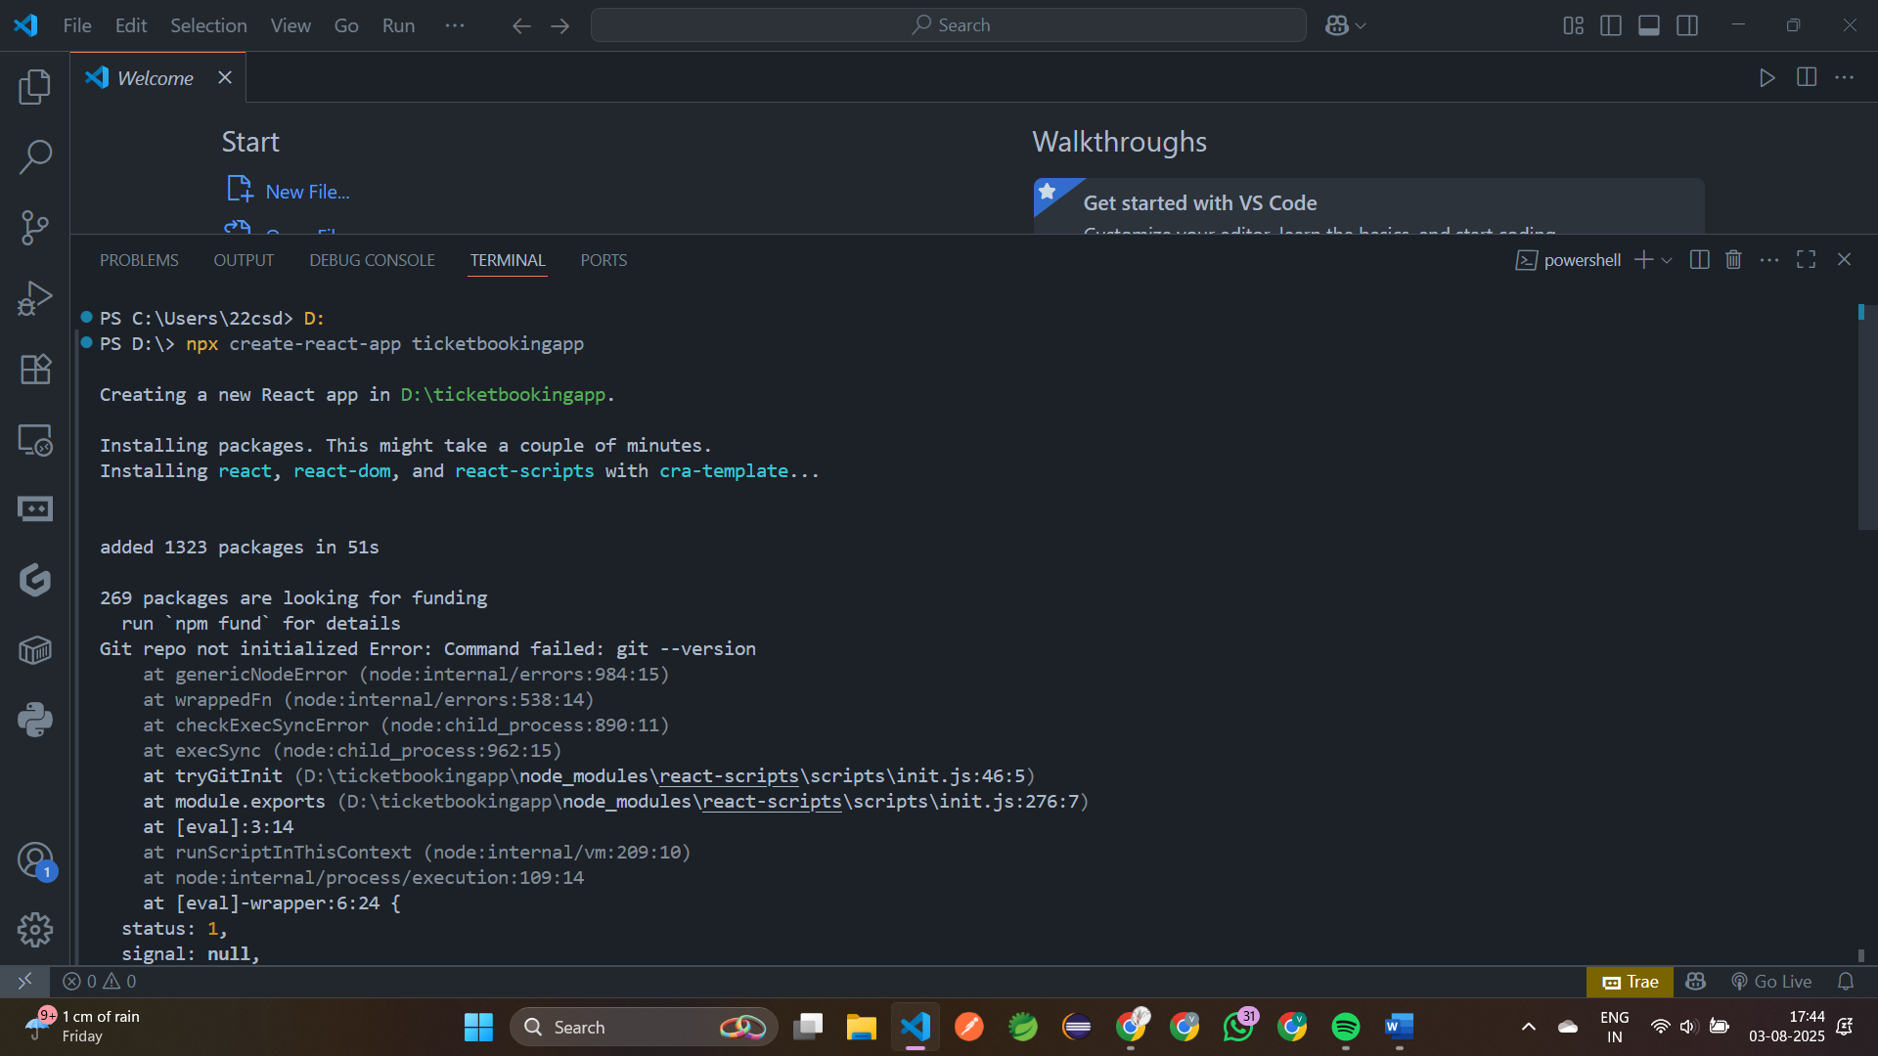

Step 4: Create a component **guestpage.js**

import React from 'react';  
 function guestpage() {  
   return (  
     <div>  
       <h2 style={{color:'red'}}>Welcome Guest!</h2>  
       <p>Please log in to book flight tickets.</p>  
       <p><u>Flight Details:</u></p>  
      <b>IndiGo:</b> Chennai to Delhi - 9:00 AM  
         <b>SpiceJet:</b> Mumbai to Goa - 11:00 AM  
     </div>  );} export default guestpage;

Step 5: Create another component **userpage.js**

import React from 'react';  
 function userpage() {  
   return (  
     <div>  
       <h2 style={{color:'red'}}>Welcome, User!</h2>  
       <p>You can now book tickets below:</p>  
       <button>Book Ticket</button>  
     </div>  );  
 } export default userpage;

step 6: Create a new file **Loginbutton.js**

import React from "react";  
 function Loginbutton({ onLogin }) {  
   return <button onClick={onLogin}>Login</button>;  
 }  
 export default Loginbutton;

step 7: Create a new file **Logoutbutton.js**

import React from "react";  
 function Logoutbutton({ onLogout }) {  
   return <button onClick={onLogout}>Logout</button>;  
 }  
 export default Logoutbutton;

step 8: Open **App.js** and modify it:

import React from "react"; import './App.css';  
 import React, { useState } from 'react';  
 import GuestPage from './guestpage';  
 import UserPage from './userpage';  
 import Loginbutton from './Loginbutton';  
 import Logoutbutton from './Logoutbutton';  
 function App() {  
   const [isLoggedIn, setIsLoggedIn] = useState(false);  
   const handleLogin = () => setIsLoggedIn(true);  
   const handleLogout = () => setIsLoggedIn(false);  
   return (  
     <div className="App">  
       <h1>Flight Ticket Booking</h1>  
       {isLoggedIn ? (        <>           <UserPage />  
           <Logoutbutton onLogout={handleLogout} />        </>       ) : (        <>  
           <GuestPage />  
           <Loginbutton onLogin={handleLogin} />  
         </>      )}     </div>  );  
 } export default App;

Step 9: Run the App using http://localhost:3000

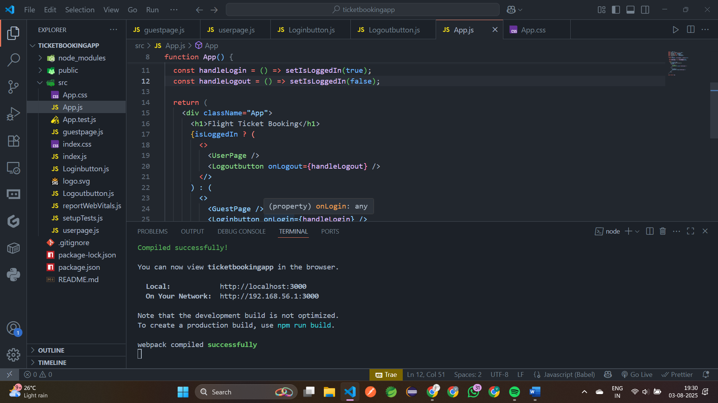

**Output:**

